MSTP-REP
Master-Slave/Token-Passing LAN Repeater

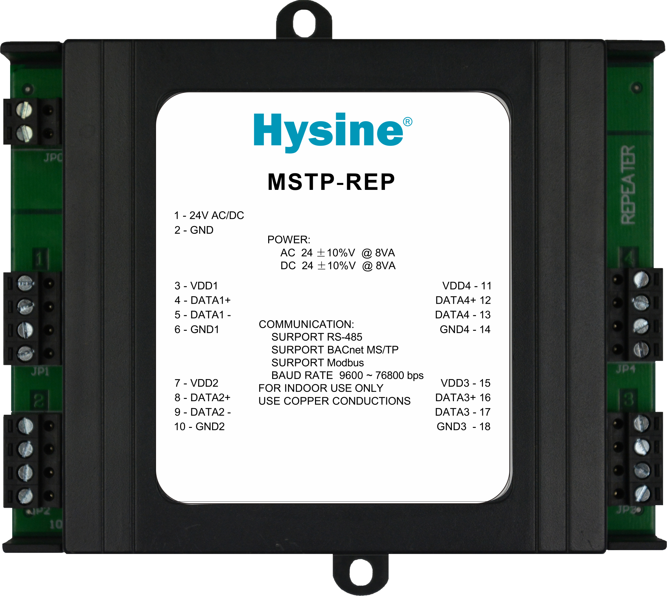
Features and Highlights
- Simple
Just physically connect without any other operation.
- Adaptive
Automatic baud rate recognition from 9600 bps up to 76.8 Kbps.
- Versatile
Designed for BACnet-based MS/TP LANs and other RS-485 based LANs such as Modbus.
- Flexible
Star-wired bus topology expands MS/TP LAN architecture options.

Applications and functions

- The Hysine® MSTP-REP is a versatile, high-performance MS/TP LAN repeater, physically connects two or more BACnet MS/TP LAN segments ,extending your network architecture options while maintaining optimum signal quality and controlling cost.
- The MSTP-REP uses the RS-485 signaling standard over twisted-pair wiring, which can run 1000 meters per segment. So the MSTP-REP gives you flexibility in the design of your BACnet LAN layout. Star-wired topology reduces the installation cost by allowing multiple MS/TP segments to communicate with a single LAN System Integrator.
- The MSTP-REP has terminals for four LAN segments. It can appear anywhere on these segments, with no upstream/downstream requirements.
- The power requirement is broader. With its simple interface and communication rates of up to 76.8 Kbps, MS/TP can be implemented at low cost.
- The MSTP-REP can also be used in other LANs based on RS-485 such as Modbus.

Ordering information
Item number Description .

MSTP-REP Master-Slave/Token-Passing LAN Repeater

Technical Data
- Power AC 9~26V @ 8VA or DC 9~32V @ 8VA. Utilizes a half-wave rectifier.
- Communication 4 BACnet MS/TP LAN segments. Switch selectable baud rate from 9.6 to 76.8 Kbps
- Signaling RS–485.
- Dimensions (120mm)H × (140mm)W × (40mm)D
- Terminations Removable header-type screw terminals accept 14-24 AWG wire.
- Environmental -17-70℃.0-95%RH,non-condensing.
- Communications BACnet MS/TP LAN from 9600 bps up to 76.8Kbps.
- Ratings EMC GB/T 17626

Dimension[mm]

