RH-xU-D-T
Duct humidity and temperature transmitter
Features
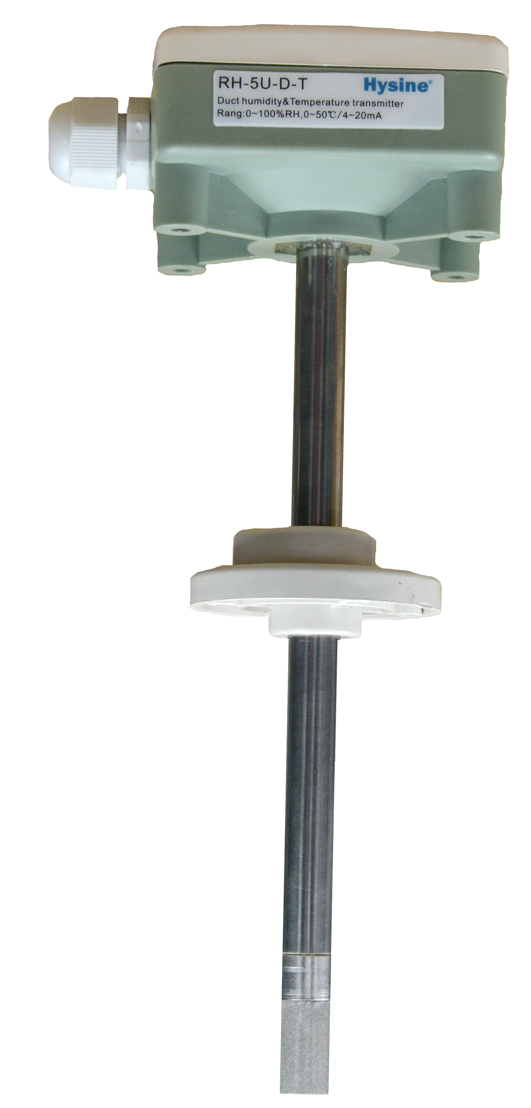
- Humidity and temperature measurement for air ducts
- Simple and secure installation
- 4…20mA measuring signals
- Compact size and modern design
Applications
- On return air ducts to measure return air humidity and temperature
- On supply air ducts to measure supply air humidity and temperature
- On fresh air ducts to measure outdoor ari humidity and temperature.
Humidity Transmitter
The transmitter measures the humidity by the honeywell humidity sensor HIH-5030. The transmitter analog output may be 4-20mA. And the transmitter include a noise filter. the power supply is large range VDC18V----VDC30V.The humidity transmitter measurement range is 5%-95%.
linearity Signal output:
HI_{MAX}
HI_{Min}
Y [%]
100%
0%
H[0-100]

Ordering
Ordering number:RH-5U-D
-5 indicates the humidity transmitter accuracy is 5%; -3 indicates 3%, -2 indicates 2%.
-U indicates the humidity transmitter signal out is 4-20mA.
-T indicates the temperature range is 0 – 50℃; -T3 indicates -20 – 60℃.
For example:RH-5U-D-T
The duct humidity and temperature transmitter signal out is 4-20mA

Installation
Duct probes should be installed directly on the duct, in an area where the air stream is well mixed:
- Locate a supply air sensor two or three meters down stream from the nearest fan and coil.
- Mount the return air sensor close to the air inlet but downstream from a return fan if one is present.
- To install the sensor, assemble base plate and probe, then drill a 12 mm hole and two 3 mm holes on a diameter of 25 mm in the duct.
- Use two self-tapping sheet metal screws to tighten the mounting circuit in the cover.
- Connect the wires according to the wiring diagram to the measuring circuit in the cover:
  - Only the humidity transmitter signal out need three terminal connections,DC24V,Ground and humidity signal out.
  - If humidity and temperature transmitter signal out need for terminal connections,DC24V,Ground,humidity signal out and temperature signal out.
  - The connection signal cable should be shield wires.
- Assemble the cover with the mounting plate.
- Insert the assembled probe through the center opening of the mounting plate into the air stream.
- Tighten the horizontal screw on the mounting plate to fix the probe to the duct.

Technical Specification
Power supply | Option voltage | DC 24V or AC 24V
Power supply | Power Consumption | Max 2 VA
Signal out | signal | 4-20mA
Signal out | accuracy | Humidity 5% ; temperature 0.5℃
Signal out | Humidity range | 0%-100%
Signal out | temperature range | 0 - 50°C
Connection | Connection Terminals | 2.5 mm²
Environment | Operation  Climatic Conditions  Temperature  Humidity | To IEC 721-3-3  class 3 K5  -40…70°C  <95% RH.
Environment | Transport & Storage  Climatic Conditions  Temperature  Humidity  Mechanical Conditions | To IEC 721-3-2 and IEC 721-3-1  class 3 K3 and class 1 K3  -40…80°C  <95% RH.  class 2M2
Standards | conform according to  EMC Standard 89/336/EEC  EMEI Standard 73/23/EEC | EN 61 000-6-1/ EN 61 000-6-3
Standards | Automatic electrical controls for household and similar use  Special requirement on temperature dependent controls | EN 60 730 –1  EN 60 730 – 2 - 9
Standards | Pollution Class | Normal acc. To EN 60 730,RoHS compliant
Standards | Degree of Protection | IP56 to EN 60 529
Housing Materials | Cover & Mounting Plate | Fire proof ABS plastic
General | Dimensions [mm] | Cover: 42 x 112 x 88 (H x W x D)  probe: ø 14 x 200 (Diameter x L)
General | Weight (including package) | 135g

Wire diagram

Terminal connections
- power supply DC24V or AC 24V
- power supply ground or signal ground
- Humidity signal output 4~20mA
- Temperature singal output 4~20mA
1
2
3
4
ADC24

GND

RH

T

dimension [mm]
81
28
15
61
12
14

81
81

