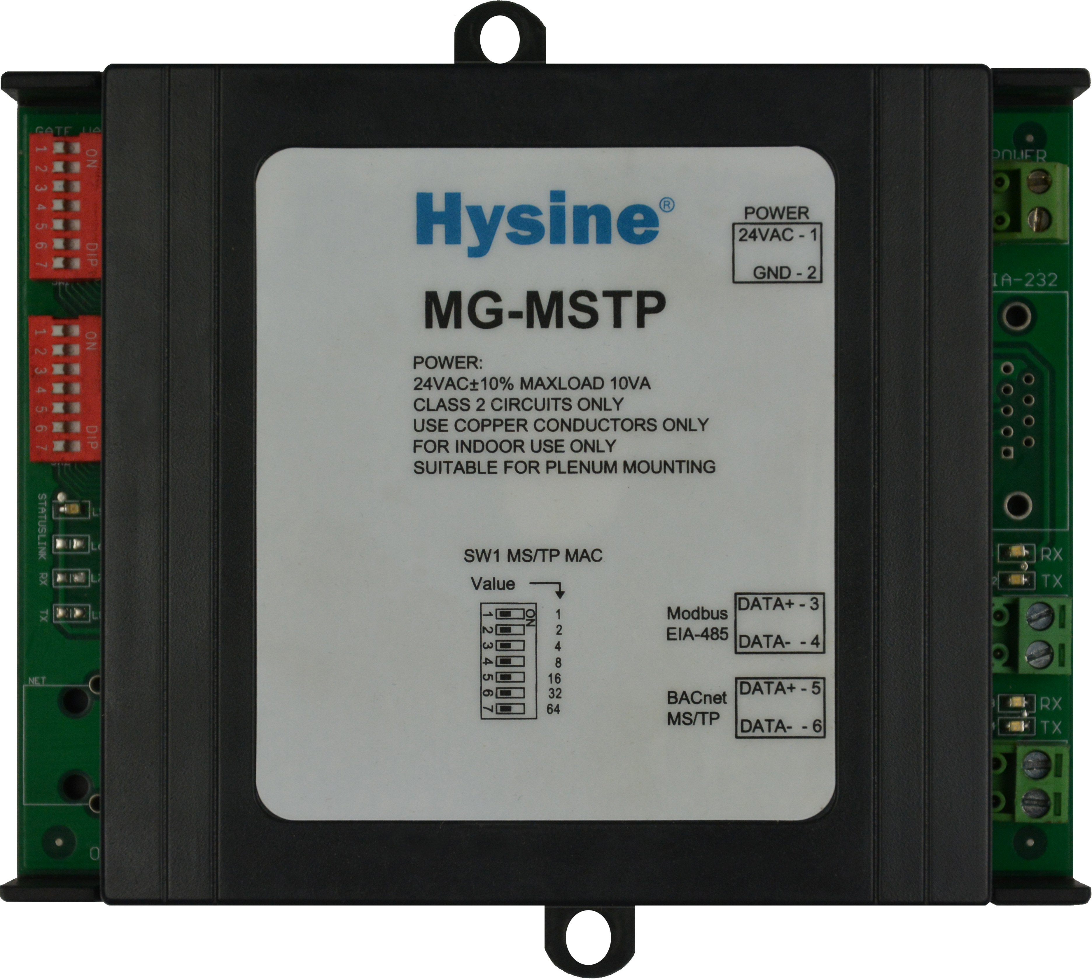
MG-MSTP
BACnet to Modbus Gate

Features and Highlights
- Interoperable
Modbus -compliant controller supports BACnet data form slave nodes on an EIA-485 network. and One MS/TP connections to Modbus internetwork.
- Versatile
Supports 100 analog and 100 binary values integrate BACnet device data with a Modbus system.
- Reliable
Extensive onboard filtering, with all program data backed up in nonvolatile flash memory.
- Ecomomical
Simple, low cost solution for field-level integration of BACnet device.

Applications and functions
- The Hysine MG-MSTP is a field-level gateway that resides on a Modbus network and connects to BACnet MS/TP over EIA-485,translating BACnet data to Modbus AVs and BVs. The MG-MSTP appears to the Modbus system in the same manner as a Modbus MCU,with a single Modbus device instance.
- The MG-MSTP offers a point capacity of 100 MOBUS AI/AO/AV and 100 BI/BO/BV an ideal point count for most BACnet applications. A single MG-MSTP supports up to 10 BACnet devices on a multi-drop BACnet MS/TP network.
- The MG-MSTP is the next-generation BACnet to Modbus gate from Hysine. Each MG-MSTP supports field controllers on one BACnet MS/TP LANs and one Modbus LANs. MS/TP is a simple twisted-pair bus with a configurable speed to 76.8 Kbps. Modbus LANs is a simple twisted-pair bus with a configurable speed to 9.6 Kbps.
- The MG-MSTP independently executes digital control(DDC) algorithms to orchestrate the operation of field controllers its MS/TP LANs. It’s programmed at a operator terminal with Hysine’s easy-to-use programming environment , conbtm. Revolutionary features like an extensive application library, dynamic real-time data updates, and self-documentation save time and ease the setup process
- CMOS circuitry,a four layer circuit board with separate ground plane, and extensive hardware software,and power-supply filtering ensure reliable and stable operatio. The CMOS processor uses an internal watchdog,and power supply voltage is monitored to provide automatic shutdown and data backup.

Ordering information
Item number Description .
MG-MSTP BACnet to Modbus Gate

Technical Data
- Power 24 VAC @ 10VA. Utilizes a half-wave rectifier, which allows a single transformer to power Multiple MGs. One leg of 24VAC connects to earth (panel) ground.
- Battery Replaceable 3.0V lithium battery provides up to 1.5 years(cumulative) real-time clock(without external power supply). Standby battery life is 10 years. Coin-cell type BR1225 or equivalent.
- Processor & memory AVR processor with onboard flash memory and RAM.
- BACnet MS/TP Removable, header-style screw terminal for 1 BACnet MS/TP(shielded twisted-pair bus)LANs,each individually configurable from76.8 Kbps.
- Modbus Communications Multi-drop EIA-485 (twisted pair) to up to 10 Modbus device. Network options configurable for ASCⅡ/RTU, 4800 and 9600 baud, even/odd/no parity, and stop bit options for compatibility with various modbus implementations.
- Dimensions (120mm)H × (140mm)W × (38mm)D
- Environmental 0-55℃.0-95%RH,non-condensing.
- Software Support for 100 BACnet AVs and 100 BVs, each mapped to a Modbus data point through a string written to the description property of the AV or BV object.
- Ratings EMC GB/T 17626

Dimension[mm]

