BCU-940
Programmable ViewLogic Controller

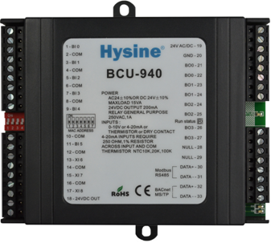
Features and Highlights
- Capable
three 10-bit universal inputs,six binary inputs,and four binary outputs,
- Interoperable
BACnet-compliant on MS/TP LAN at up to 76.8Kbps
- Versatile
Fully programmable for central plant systems, air handing units ,other control and process equipment.
- Reliable
Extensive on-board filtering, with all program data backed up in nonvolatile flash memory.
- Fast
Internal logic loop of 100msec

Applications and functions
- The Hysine® BCU-940 is a versatile, high-performance BACnet-compliant field controller designed for of central plant systems, air handling units, large terminal units, and similar control and seamlessly with your BACnet system. It communicates at up to 76.8Kbps on a BACnet MS/TP LAN or can operate as a stand-alone controller.
- ALL BCU-940 control logic is programmed with Hysine’s easy-to-learn graphical programming language，ViewLogic。This self-documenting software’s complete function library enables you to implement entirely flexible control strategies. A single BCU-940 can contain numerous algorithm loops that control various parts or multiple pieces of equipment.Programming and setup data is stored in non-volatile flash memory, and each BCU-940 contains its own software time schedule,ensuring stable and reliable operation.
- The BCU-940 supports the OP-800 intelligent operation display panel, which offer convenient data display，setpoint adjustment, and technician to equipment setup parameters.
- The BCU-940 is built for high-speed processing ,with an internal logical loop time of 100msec. Programmable timers also maintain a resolution of 100msec.
- High-resolution,10-bit analog inputs are field-adjustable for thermistor/dry contact,4-20 mA or 0-10 VDC.Analog outputs are 0-10 VDC(AO0)
- CMOS circuitry,a four layer circuit board with separate ground plane, and extensive hardware software,and power-supply filtering ensure reliable and stable operatio. The CMOS processor uses an internal watchdog,and power supply voltage is monitored to provide automatic shutdown and data backup.

Ordering information
Item number Description .
BCU-940 Field controller with three universal inputs and six binary inputs
Four binary outputs,one analog outputs.

Technical Data
- Power 24 VADC @ 10VA. Utilizes a half-wave rectifier, which allows a single transformer to power Multiple BCUs. One leg of 24VDAC connects to earth (panel) ground.
- Universal Inputs three universal inputs with 10-bit resolution. 0~10v or4~20mA or Thermistor orcomtact,4~20mA inputs require 250 ohm,1%Resistor across input and com.
- Binary Outputs 4 relay outputs,each contact rated at 277VAC,2A.
- Analog Outputs 1 analog outputs with 8-bit resolution. 0-10VDC min.load resistance is 500 ohm.
- 24VDC Outputs Two terminals provide up to200mA(total)of 24 VDC to power transducers.
- Processor & memory AVR processor with onboard flash memory and RAM.
- Dimensions (120mm)H × (140mm)W × (40mm)D
- Terminations Removable header-type screw terminals accept 14-24 AWG wire.
- Environmental -17-70℃.0-95%RH,non-condensing.
- Communications BACnet MS/TP LAN up to 76.8Kbps.
- BACnet conformance An application specific controller (ASC).
- Ratings EMC GB/T 17626

Dimension[mm]

